Q1-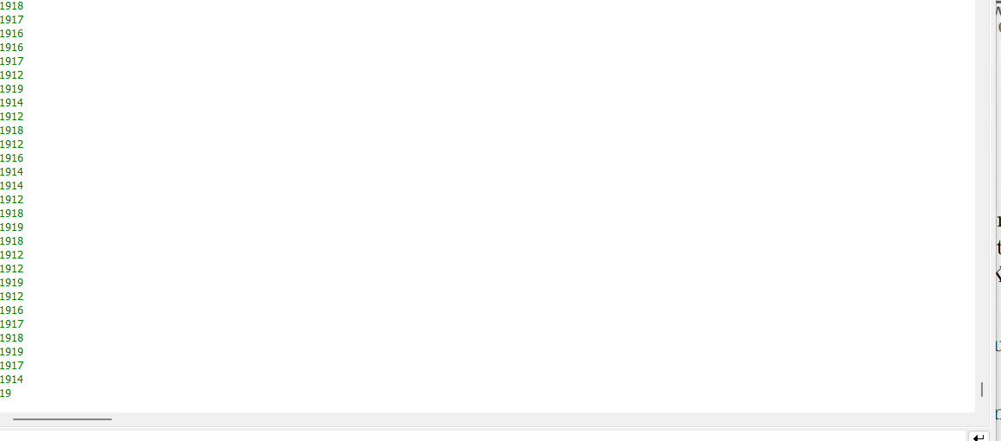

Q3-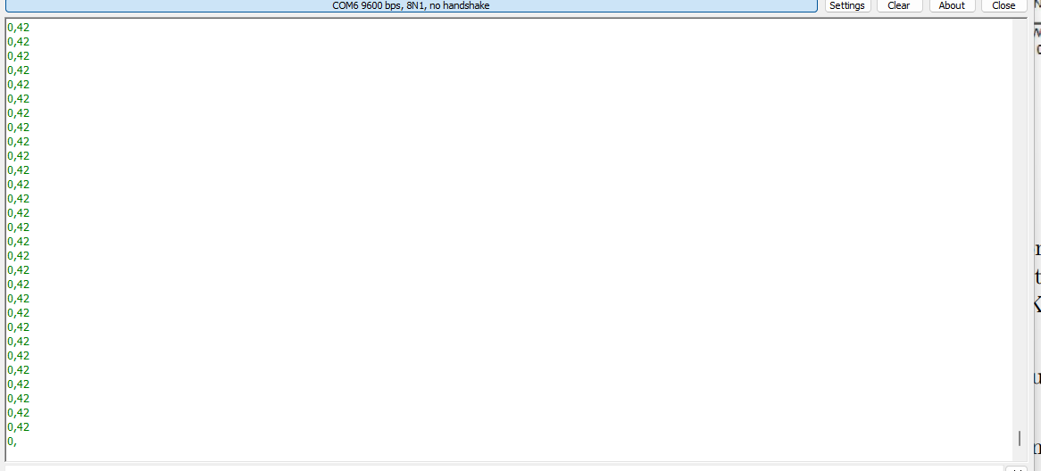

Q4-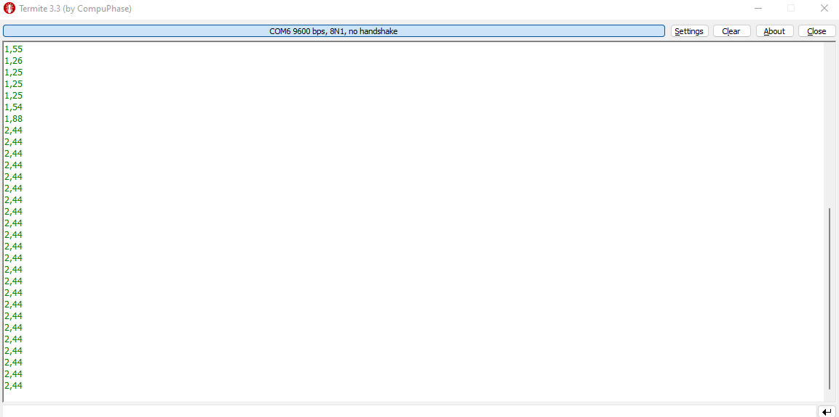

Q5-

